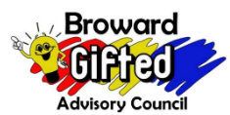 Broward County Public Schools

**Gifted Advisory Council- General Meeting**

Via Microsoft Team

January 8th, 2024, 7:00pm

**Email**: [BrowardcountyGAC@gmail.com](mailto:BrowardcountyGAC@gmail.com) **Website**: <http://giftedadvisorycouncil.ch2v.com/>

Chair: Karla Figueroa, Vice Chair: Allan Bushkin, Recording Secretary: Erin Kirkland, Corresponding Secretary: Diego Britto, Parliamentarian: Cynthia Dominique

**AGENDA**

1. Call to Order
2. Introductions
3. Meeting Etiquette
4. Chair Report
5. Parent Resource
6. Announcements
7. Q&A
8. Adjourn

**